Case 19-Am,C-Taino-Amulet-Anthropomorph-Kneeling-with Cap-Manatee Bone

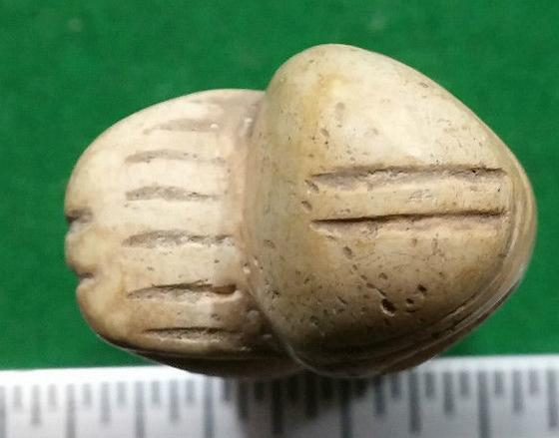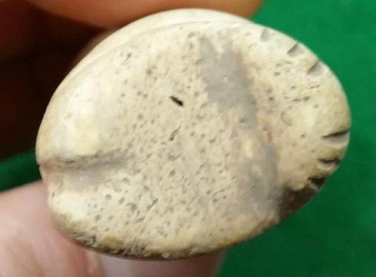

Top View Bottom View

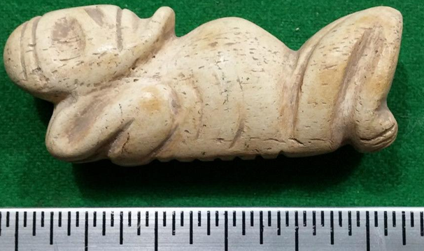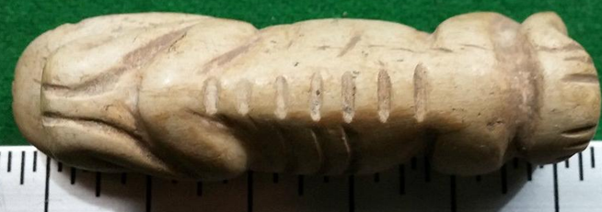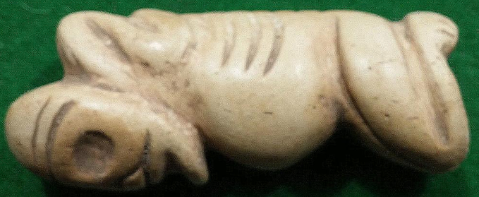

**Case No.: 19**

**Accession Number:**

**Formal Label:** Am,C-Taino-Amulet-Anthropomorph-Kneeling-with Cap-Manatee Bone

**Display Description:**

This depiction of a kneeling anthropomorph may be a shaman since its arms are shown in a ritual pose behind the head, its ribs are carefully marked as being subject to abstinence and its spine is marked as the stages of trance experiences encountered. The figure also wears a cap which is also typical of Taino shamans.

**LC Classification:**

**Date or Time Horizon:**

**Geographical Area:**

**Map:**

**GPS Coordinates:**

**Cultural Affiliation:**

**Medium:**

**Dimensions**:   
**Weight:**

**Provenance:**

**Condition:**

**Discussion:**

**References:**